Lab Exercise 6.2
Creating a New Jenkins Job to Checkout Source Code

Objective: To set up a Jenkins job to manage source code, specifically by configuring the Source Code Management section to check out code from a Git repository

Tools required: Jenkins

Prerequisites: Jenkins must be operational.

Steps to be followed:
- Log in and create a Jenkins job
- Configure source code management

Step 1: Log in and create a Jenkins job

- Navigate to localhost:8080 in your web browser, enter your credentials, and click on Sign In

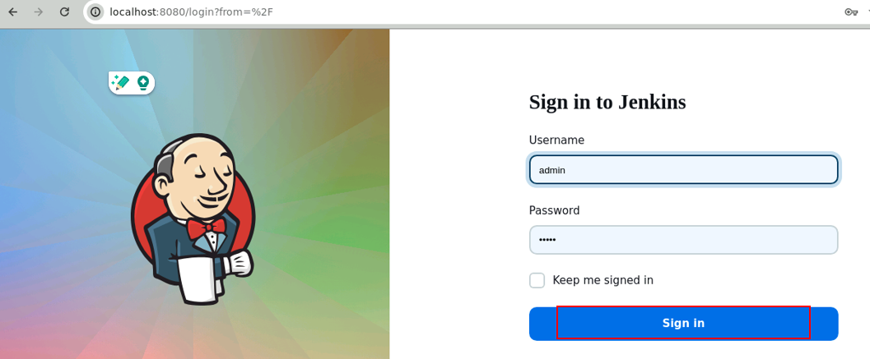
Note: The credentials for accessing Jenkins in the lab are Username: admin and Password: admin.

- Create a new Jenkins job by clicking on New Item

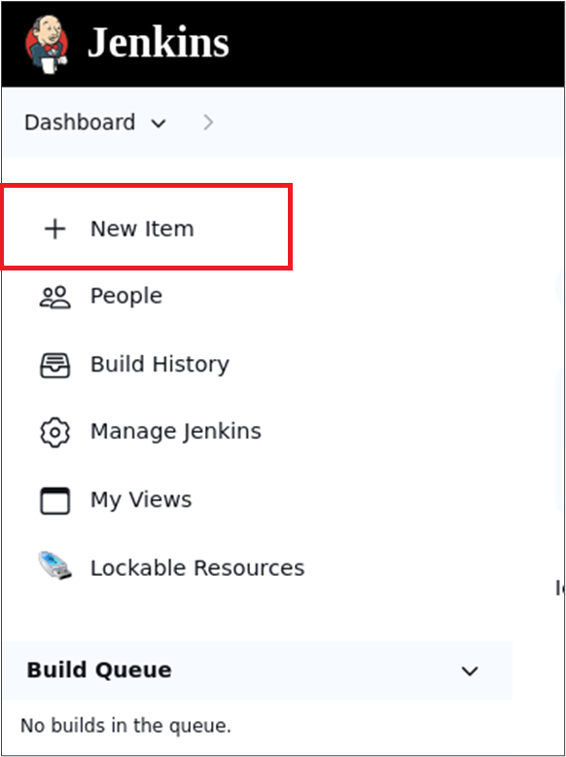

- Provide custom job name inside the field Enter an item name, select the Freestyle project option, and click on the OK button to save the job

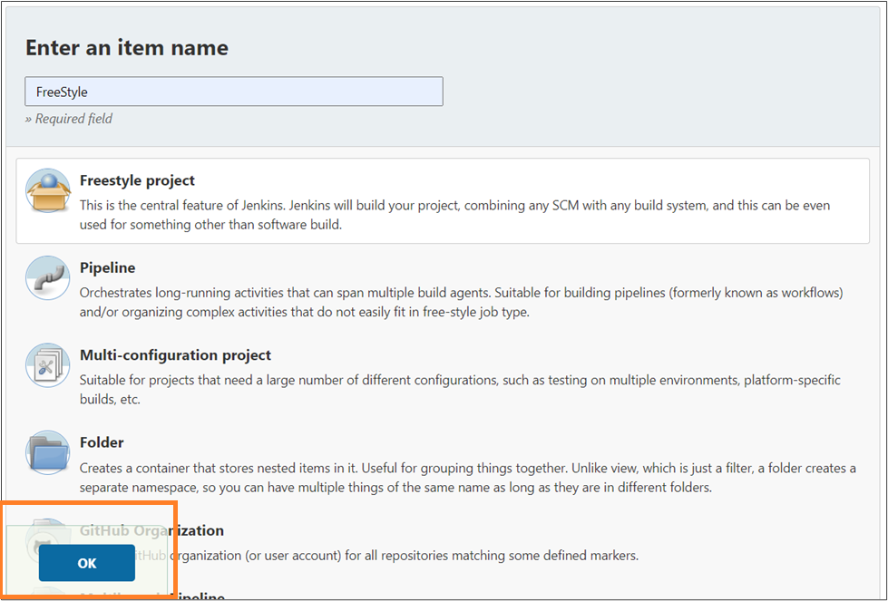

Output:
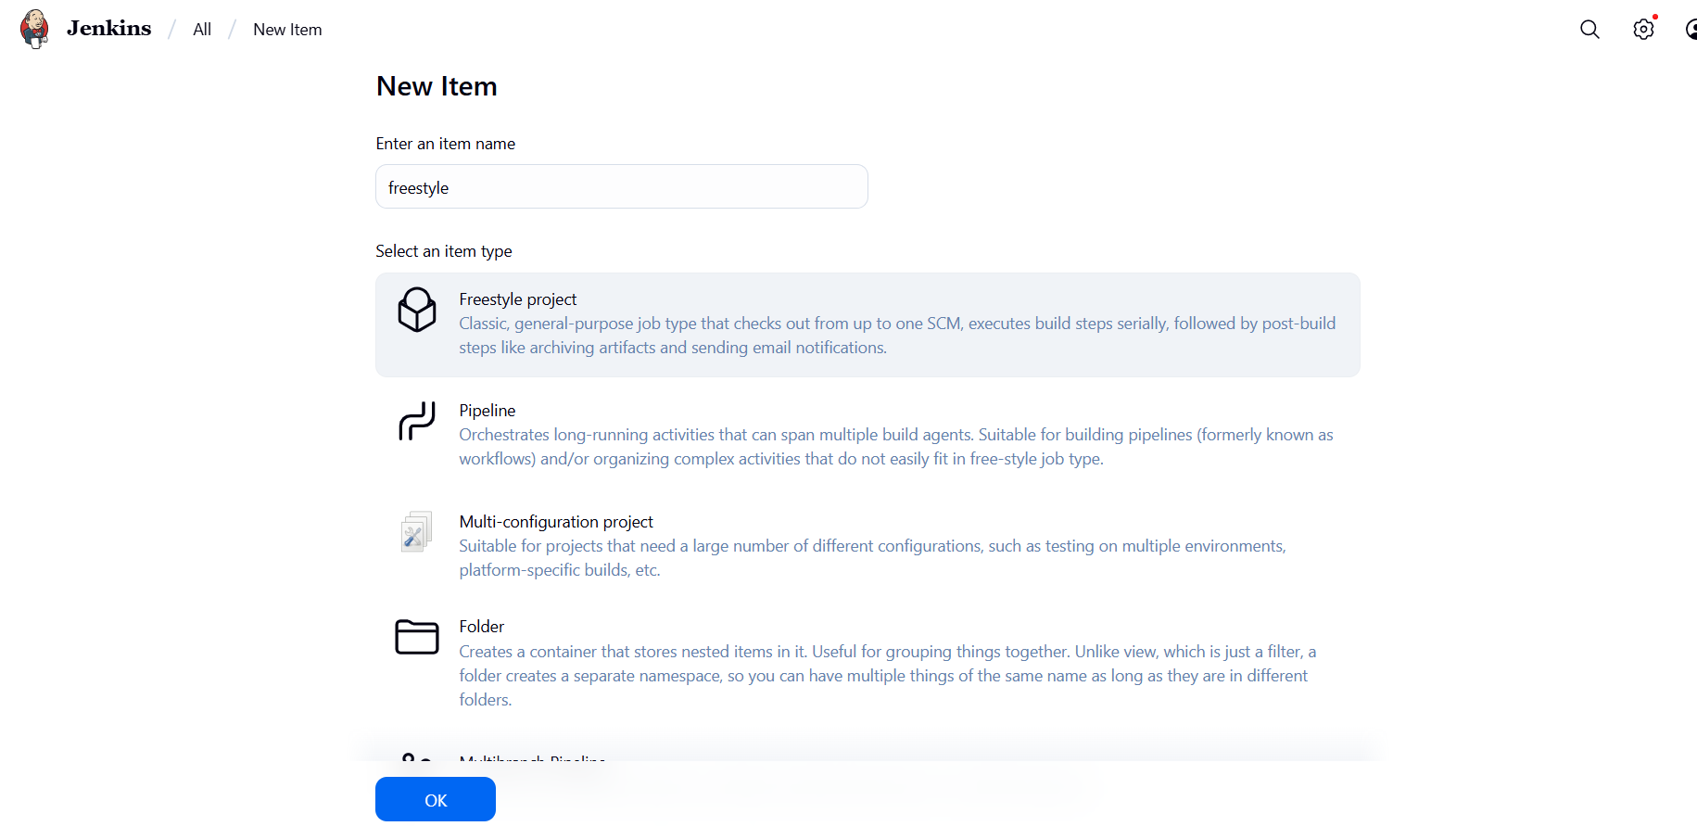

Step 2: Configure source code management

- Access the newly created job's configuration screen by clicking on Configure

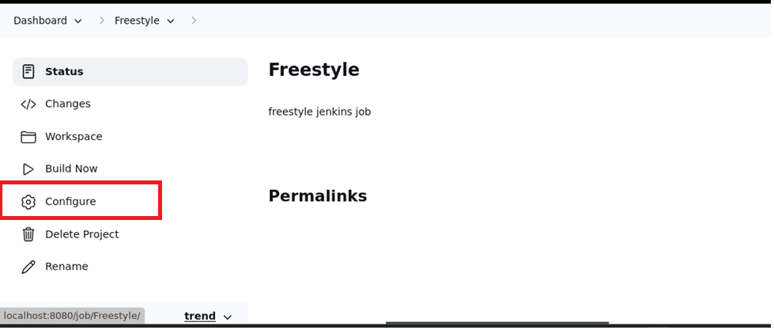

- Navigate to the Source Code Management tab, provide Git repository configuration inside the Repository URL field, and click on the Save button

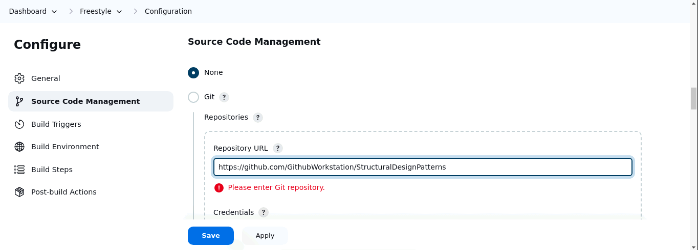

- Then, click on the Build Now option to schedule a build

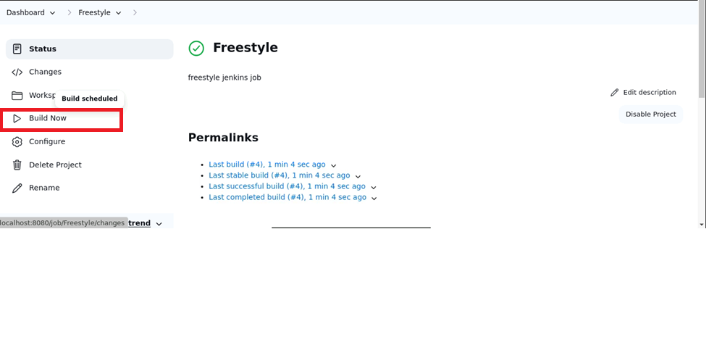

- To schedule the build, click the required link under Permalinks

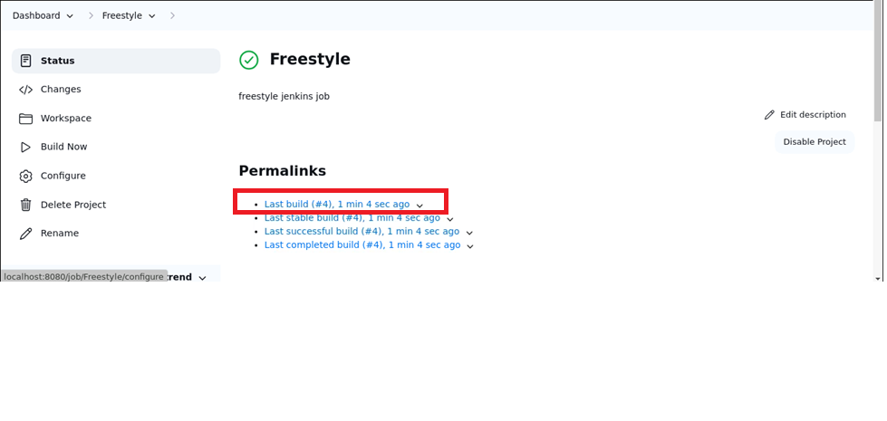

- Click on Console Output to check out the process during the build process

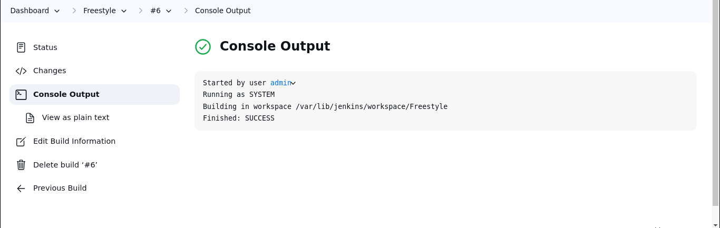
By following these steps, you have successfully set up a Jenkins job to automatically check out source code from a Git repository, enabling seamless integration and automation in your CI/CD pipeline.
Output:
